**DESIGN DOCUMENT**

**TITLE:** Battleship Program

**Author:** Lucas Fulmer

**Problem Description:** This program creates a “Battleship” style game. The game requires the creating of multiple 10x10 grids, where the user and the computer opponent can place his/her ships. Each player also has a second grid which shows the location of torpedoes fired as well as “hits” to enemy ships. The game terminates when one player has destroyed or “sunk” all of the opponent’s ships. The program will read-in ship locations from a file for the user or allow the user to place them manually.

**Overall Software Description:** The program contains three classes. The first is class “Player” which has two derived classes. The second class “Grid” is a derivative class of “Player.” The final class is “WaterVehicle” which creates the ships. The “WaterVehicle” class is also a derivative class of “Player.” Grid is responsible for creating up to four 10x10 grids and displaying the ship and torpedo locations. Grid has multiple functions which allow the players to choose coordinates for torpedoes and to output the grids. WaterVehicle creates the ships for both players and has functions which determine ship’s size, starting location, orientation, and whether the ship is sunk.

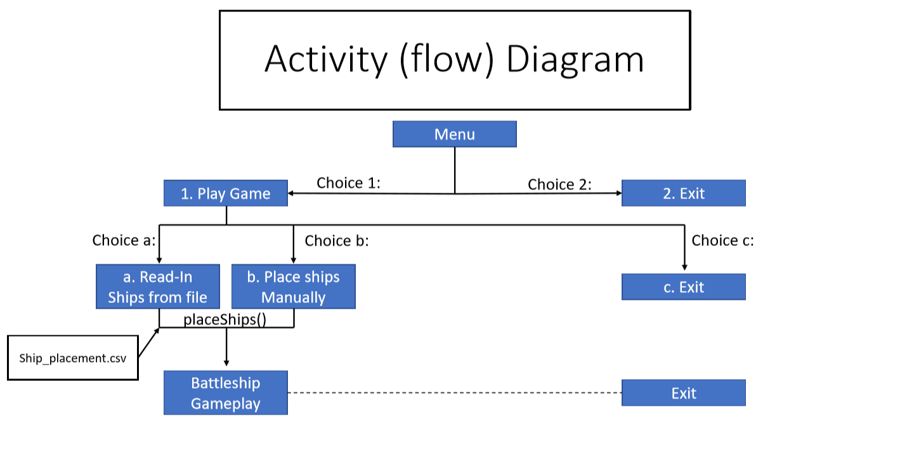

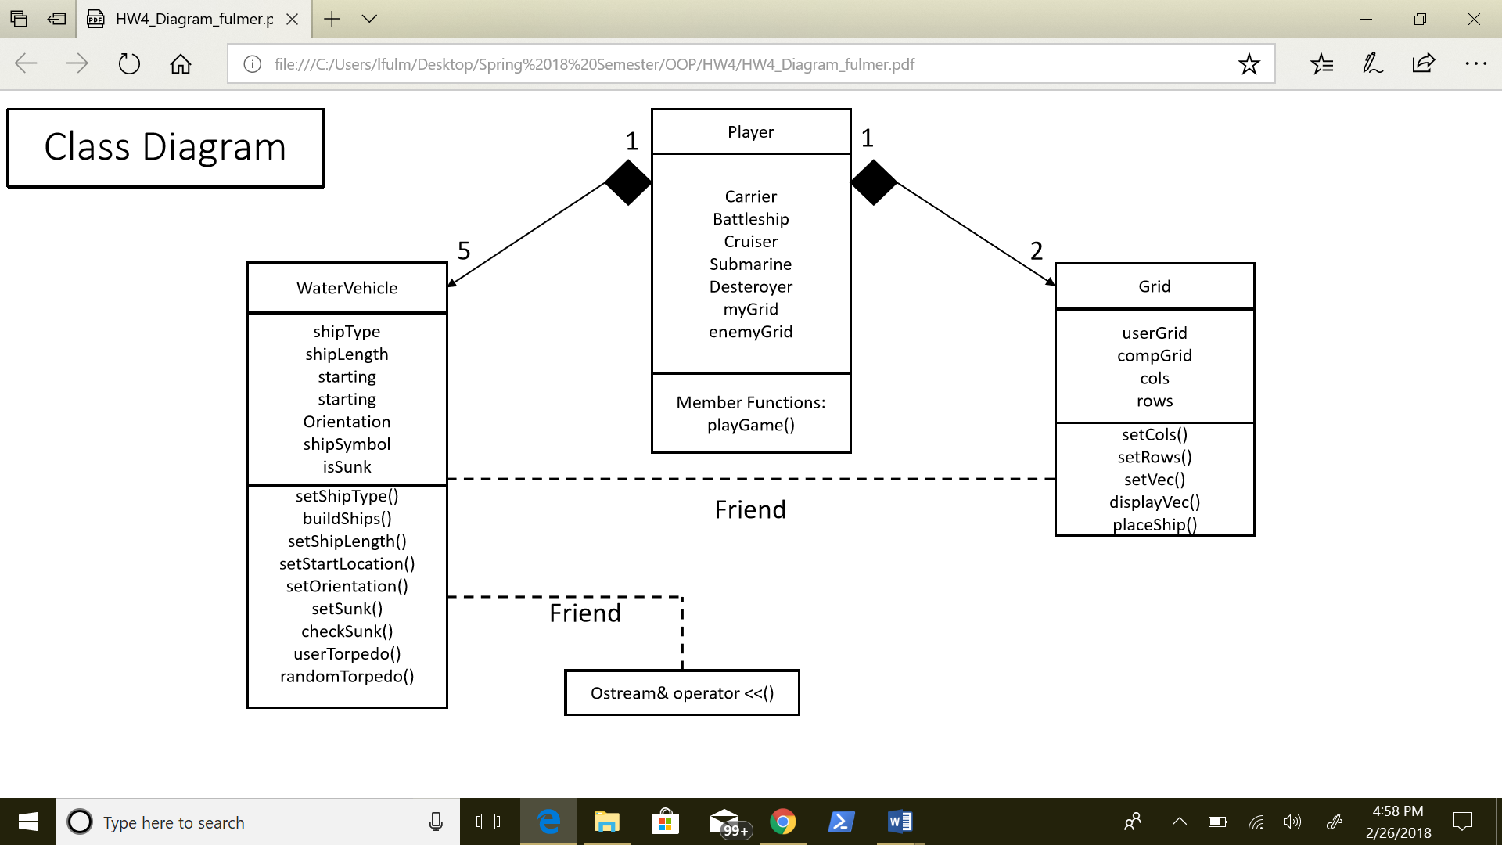

**Input Requirements**

**Main Menu:**

Keyboard input (requires user to choose an integer of 1. Play Game or 2. Exit)

**Ship Placement:**

Keyboard input (requires user to choose upper case or lower case character ‘a’, ‘b’, or ‘c’)

1. File read in (ship_placement.asv)
2. Manual ship placement
   1. Keyboard input (user chooses upper or lower case character ‘a’ – ‘j’)
   2. Keyoard input (user chooses integer 1 – 10)
   3. Keyboard input (user chooses upper or lower character ‘v’ or ‘h’
3. Exit program

**GamePlay:**

User prompted for torpedo location –

Keyboard input (user chooses upper or lowercase character ‘a’ – ‘j’)

Keyboard input (user chooses integer 1 – 10)

Optional keyboard input (user enters character ‘q’ to quit game)

**Output Requirements**

**Main Screen**

Print menu choices

**Ship Placement**

Print ship placement options

1. Read in ship location from file
   1. Print 10 x 10 grid showing ship locations
2. Manually place ships
   1. Print 10 x 10 grid after each ship is placed

**Gameplay**

Print user 10 x 10 grid with ships

Print blank 10 x 10 torpedo grid

Print hit, miss, and sunk when when applicable

**End of Game**

Print ship statuses (name, length, starting grid, isSunk)

**Problem Solution Statement**

In order to develop this program, I am using three classes: Player, Grid, and WaterVehicle. When the program begins, it creates five WaterVehicles according to the Battleship game. It then allows for the user to choose whether to place ships manually or to read in the locations from a file. Regardless of the users decision, the function place_ships() will be called which passes the private members starting X, starting Y, and orientation (from WaterVehicle) into the user’s grid. After all ships are placed on the user’s grid, ships will be placed randomly for the computer. The program will alternate between user input torpedo shots and randomly generated computer shots, until all ships are destroyed or the user quits the game.

**Classes, Inheritance, and Data Structures**

This program uses three classes: Player, Grid, and WaterVehicle. Grid and WaterVehicle are both derivative classes from Player. Using class Player, I create the user’s player object and the computer’s object. Each “Player” has two grids and five WaterVehicles. For the creation of grids, I chose to use vector data structures. I chose vectors as opposed to arrays because, it leaves the opportunity to change the size of the grids. If we decide to make the game more complex we could easily adjust the size of the grids and/or increase the number of ships. Using a multi-dimensional array would have worked easily and would still have allowed for easy indexing. Although the set size would most likely be adequate for the assignment, it would be more difficult in the event that we wanted to allow the user to choose the size of the grid.